One-to-One Bespoke Training Application
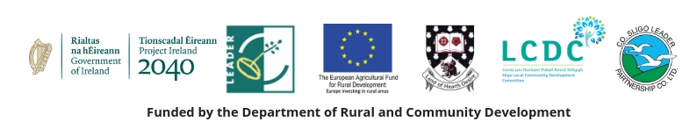
Applicant Details
Organisation Name

Year Established

Nature of Activities

Board/Committee Structure

Staff/Volunteers Structure

Name of Contact Person
Contact Person Email/Telephone Number

Bespoke Training Request

What are the principle issues, problems or challenges that the organisation is currently trying to address?

In what ways do you believe that bespoke training may be able to help you to address these issues, problems or challenges?

Who will participate in bespoke training on behalf of your organisation?

Your personal data will be used to issue email and telephone communications about this one-to-one bespoke training application and to record your interest in training on our database. This page will be deleted within 10 days post application assessment. The record of your interest in receiving bespoke training will be deleted from our database seven years after the end of the project delivery period. Further information on the privacy statement of Co. Sligo LEADER Partnership CLG can be provided on request.

